Concept Generation and Testing

Concept Generation

In this step, we generated the concepts of our product, and developed a prototype using drawings below to show functions and application scenarios.

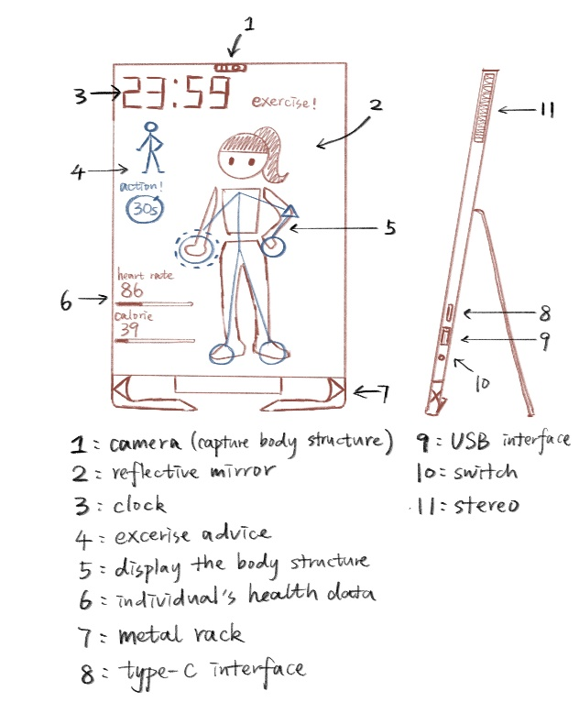 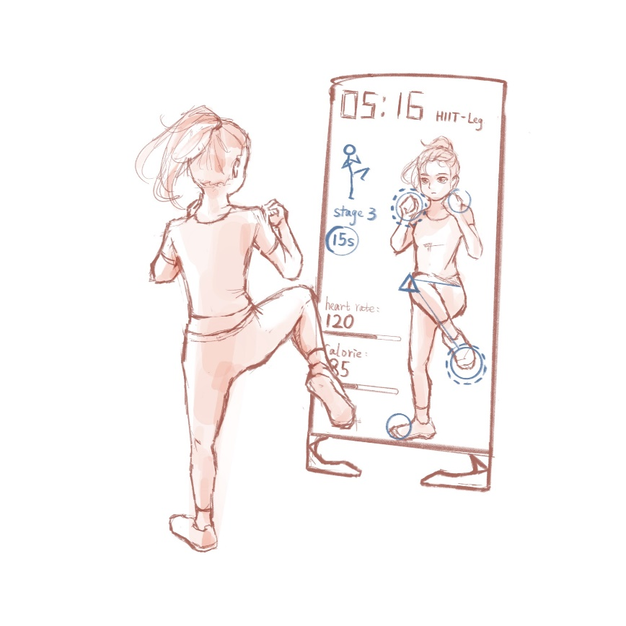

The Steps for generating concepts are as follows:

Step1: Clarify the problem

1. Understanding the problems

a) The product is exquisite in shape and portable in size.

b) The product can use the somatosensory function to monitor human data.

c) The product allows users to interact socially.

d) The product has the function of personalized customization for users.

e) The product can connect to external devices through external connections.

2. Problem decomposition

In this part, we divided the problems mentioned above given their different technology application fields, so as to find out critical sub-problems exactly later. The figure below indicates the results of problem decomposition:

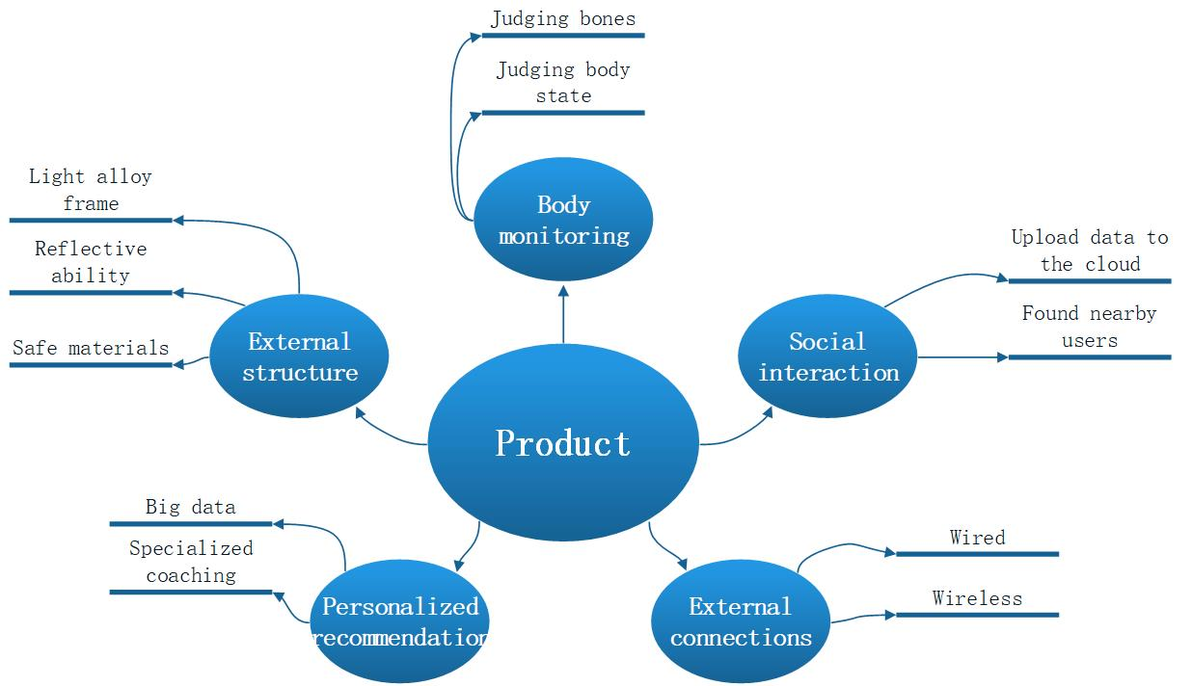

3. Focus on critical sub-problems

We believed that the following problems were the technical cores of the product and had decisive impacts on the user experience: 1. Equipment materials 2. Body monitoring 3. Personalized customization 4. External connections

Step2: Search externally

In this step, external data were obtained by searching literature and interviewing and searching for lead users' comments on the existing concepts of designs and technologies.

**1. Lead users**

**Equipment materials：**

a) Aluminum alloy support frame, whose surface is solid and weight is light;

b) IPS (In-panel Switching) screen combined with cameras, which is wide and clear;

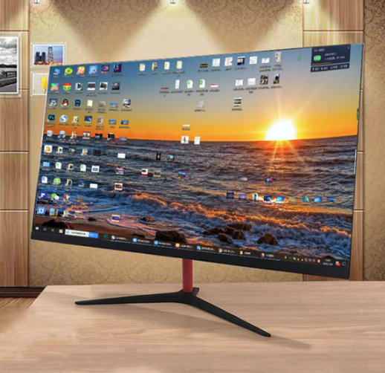

**2. Literature**

**Personalized customization:**

a) A system using Spark streaming, HBase, MySQL and Hive.

The system can rearrange multiple recall sources such as collaborative filtering, similar courses and popularity according to users' real-time preferences to generate real-time recommendation results.

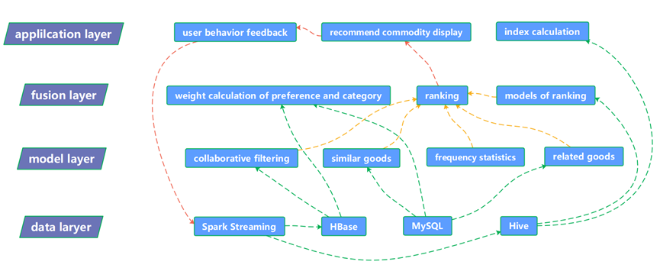

**External connections:**

a) Bluetooth technology, which is the fusion of wireless communication and data communication. The technology is based on low-cost, near-field wireless connections that can set up communication environments for both fixed and mobile devices.

b) USB interface, which is an external bus standard used to regulate the connection and communication between computers and external devices.

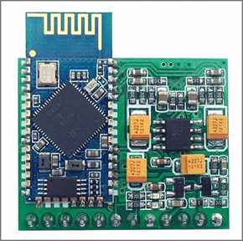 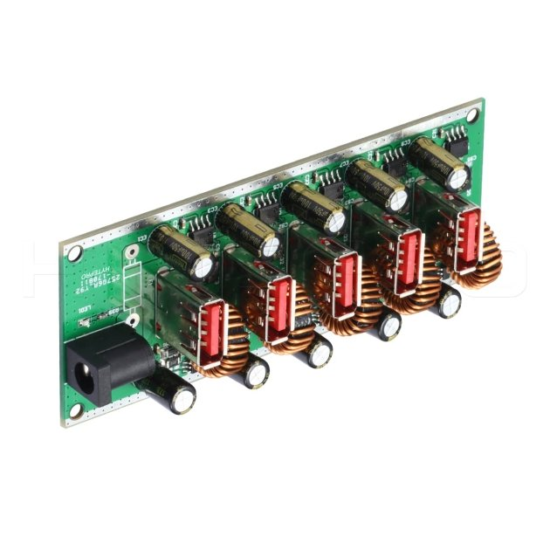

**3. Patents**

**Body monitoring:**

a) NPU neural network recognition technology

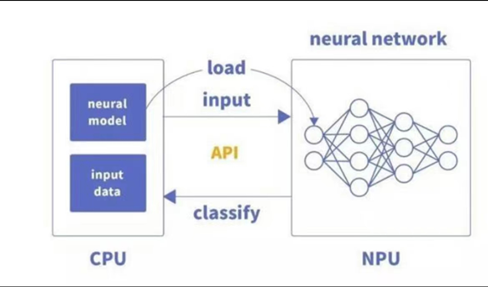

b) Intelligent interactive knowledge system

c) Intelligent sensor

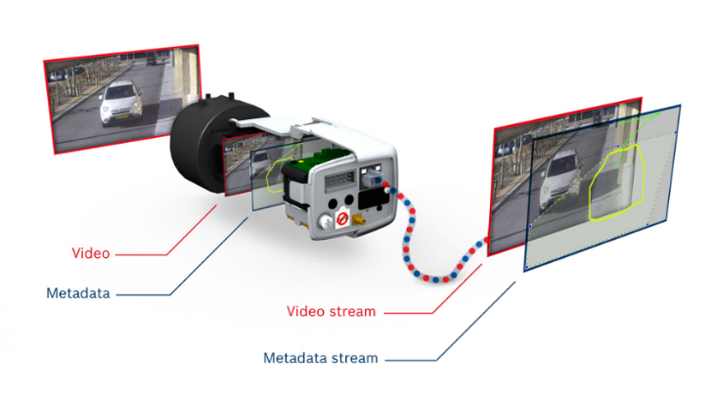

Step3: Search internally

In this step, we expressed our opinions individually in the group meeting, then we had a discussion about all group members’ thinking. We generated new concepts of designs and technologies which could be used in our product.

**Equipment materials:**

a) Use a mirror as the display screen, so as to realize the reflective function

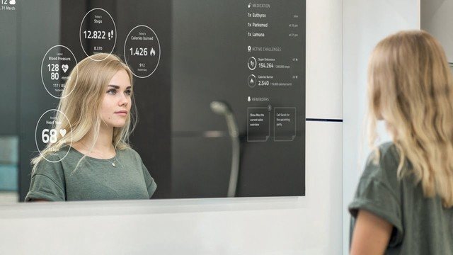

**External connections:**

a) UWB wireless communication technology, which include wireless communication and positioning functions. It has high data transmission rate and well-performed security. Users can find nearby users quickly.

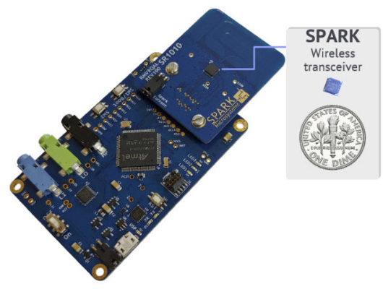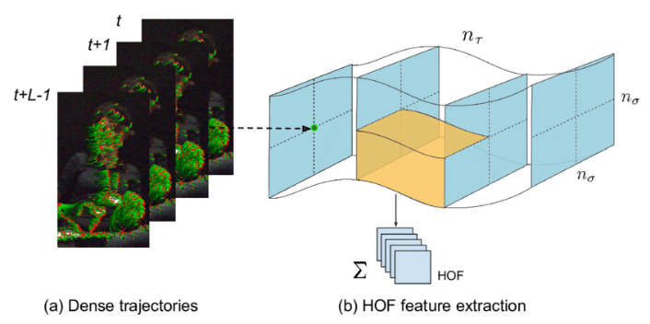

**Body monitoring:**

a) Machine learning combined with the image recognition based on CNN.

b) Dense trajectory analysis, which is to conduct intensive sampling for the live video, track the sampled points to obtain the trajectory, and then do the behavior recognition with extracting the characteristics of the trajectory.

**Personalized customization:**

a) Collaborative Filtering, which can use the user's historical selection information and similarity relationship, collect the evaluation information of other users with the same interests and hobbies to generate recommendations.

b) Mining of spatial association rules based on Apriori algorithm.

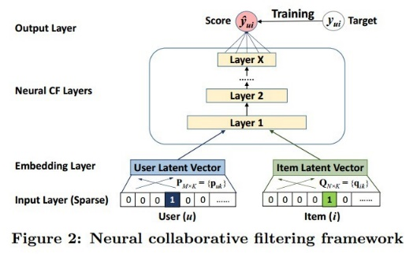

Step4: Explore systematically

In this step, we combined both existing and new sub-problems solutions, which could be combined into overall solutions.

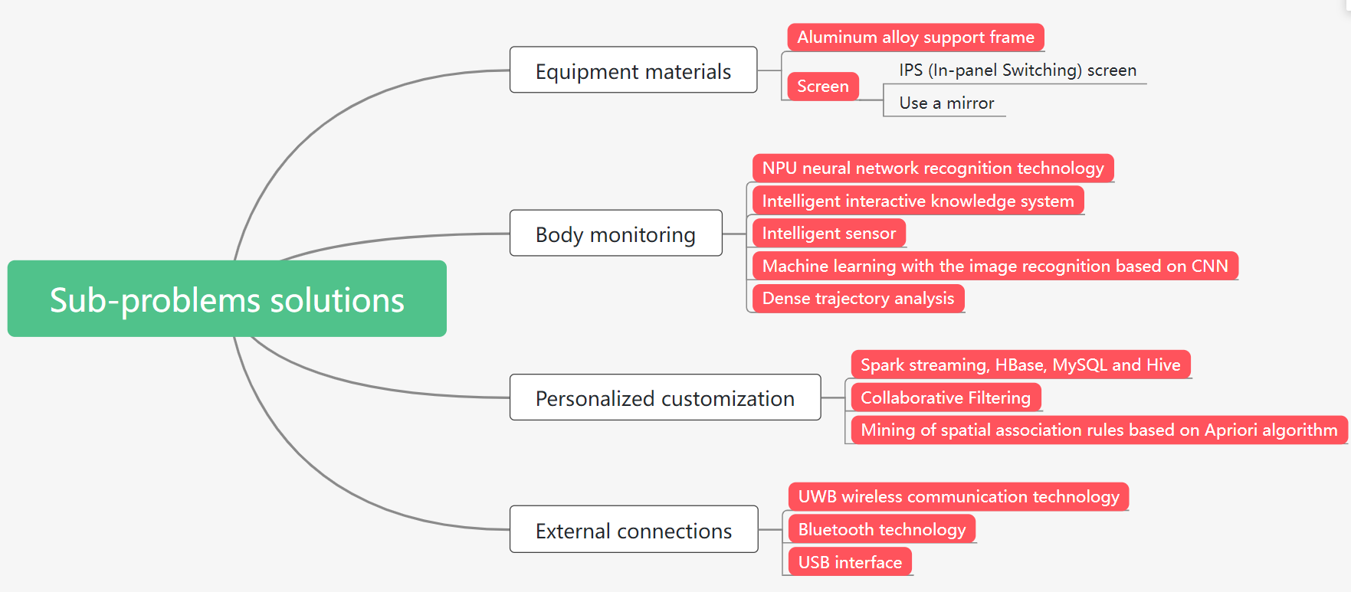

Step5: Reflect on the solutions and process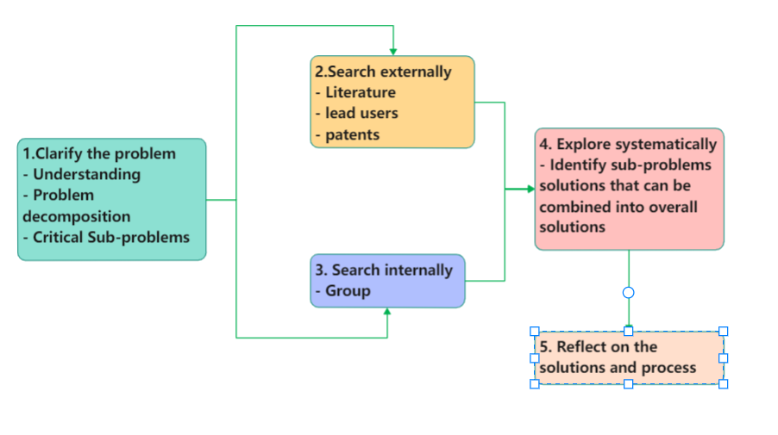

After the above steps, we thought this intelligent fitness device was feasible. Firstly, we discussed the functions of the product and decomposed problems, so as to get critical sub-problem. Then, we further investigated the comments of leading users, learned about the analysis of existing concepts by literature, and searched patents to obtain the latest information. In addition, our internal group members made further thinking and obtained the solution of the sub-problems after comprehensive consideration. Therefore, we had reasons to think that we had come to the complete concepts.